GOVERNMENT ENGINEERING COLLEGE,
BANSWARA (Raj.)


PROJECT REPORT
ON
ELECTRIC VEHICLE’S

Submitted By; Submitted To;
Shubham Sharma Vijay Kumar Gupta

ABSTRACT
“The shift to electric cars will come faster and in a more pronounced way, fueled by the diesel demise in Europe, battery technology advancements and regulation in China and Europe,” prophesied the report.
In India, the automobile industry is one of the key sectors driving economic growth. More than 25 Mn vehicles including passenger vehicles, commercial vehicles, three wheelers and two-wheelers were produced in FY17, reporting a jump of 5.41% from the previous fiscal. However, it is also one of the biggest contributors of pollution, which incidentally keeps the country’s capital shrouded in smog for several months every winter.
As India hurtles towards an apocalyptic future, the Indian government is now racing to switch to all-electric cars by 2030. While the report by UBS might be an overly optimistic take on what the future of electric vehicles will look like, one cannot overlook the massive strides the industry has made in the last decade or so.
In India, despite a myriad of challenges and obstacles, electric vehicles (EVs) are steadily gaining traction, thanks in part to favourable government initiatives and the entry of international players like Honda, Suzuki, Ford, Toyota, Volvo and Hyundai as well as startups such as Ather Energy, ION Energy, Ultraviolette Automotive, among others. Having won the first global tender for supplying 10,000 electric cars to government-run EESL, Tata Motors and Mahindra and Mahindra are the two homegrown automotive giants that are currently leading the electric vehicle revolution in the country.
In light of this burgeoning potential, we at Inc42 wanted to create a comprehensive series that not only traces the history and scope of the global EV market but also delves into the challenges, opportunities and the future electric vehicles hold in India.

The Fascinating History Of Electric Vehicles: From 1837 To Present
Electric vehicles, as the name suggests, run at least partially on electricity. Instead of fossil fuel-driven internal combustion engines, these vehicles are powered by electric motors for propulsion. The electric motor, in turn, derives energy from rechargeable batteries, solar panels or fuel cells.
Historically, electric cars have been around for more than a century. Interestingly, the first known electric car was built in Aberdeen, Scotland way back in 1837. Exhibited at the Royal Scottish Society of Arts Exhibition in 1841, the vehicle, weighing seven tons, could carry a load of six tons at speed of around four miles per hour over a distance of one and a half miles.
Its arrival coincided with the growing status of electricity as one of the preferred methods for vehicular propulsion. Additionally, with the invention of rechargeable batteries in 1859, innovations around EVs slowly, but steadily, started emerging. Incidentally, towards the end of the 19th century, battery-powered electric cabs started playing on the streets of London and New York.
The first known electric car was built in Aberdeen, Scotland way back in 1837.
In London, for instance, Walter C. Bersey built a fleet of electric taxis, called “hummingbirds”, which became operational in 1897. Around the same time, New York-based company, Samuel’s Electric Carriage and Wagon Company, designed around 62 electric cabs.
Despite its early popularity, however, electric vehicles witnessed a decline globally in the first half of the 20th century. Lack of proper charging infrastructure and simultaneous improvements in road infrastructure resulted in the dwindling popularity of EVs. At the same time, with the advancements of the automobile industry, car owners were increasingly looking for vehicles with greater range and speed than electric cars.
However, by the 1960s, EVs once again started garnering the interest of automakers. In 1959, for instance, the American Motor Corporation entered into a joint research agreement with Sonotone Corporation to develop an electric car powered by a “self-charging” battery.
In the decades since then, numerous electric car concepts have been showcased around the globe, including the Scottish Aviation Scamp (1965), the Electrovair (1966), the Electron (1977). Tracing the history of electric vehicles, we found that the first modern version of the electric car, as we know it today, was built in the early 2000s.
In 2004, Elon Musk-founded Tesla Motors started working on the Tesla Roadster, which was the first highway-legal all-electric car running on lithium-ion batteries. Over the years, most carmakers have jumped on the EV bandwagon, with Tesla, Ford, Nissan, Hyundai, Toyota and others leading the race.

So What Basically Are Electric Vehicles?
Touted as the future of mobility, electric vehicles (also known as electric drive vehicles), are fitted with onboard batteries which, unlike conventional fuel tanks, can be charged using electricity. These batteries, in turn, store and use the energy needed to power a set of electric motors, which ultimately propels the car forward.
Because an electric car is devoid of clutch, gearbox and even an exhaust pipe, it is significantly quieter and offers a smoother ride than conventional gasoline-driven vehicles. When fully charged, a standard EV is capable of covering somewhere between 150 km to 170 km before it needs to be recharged.
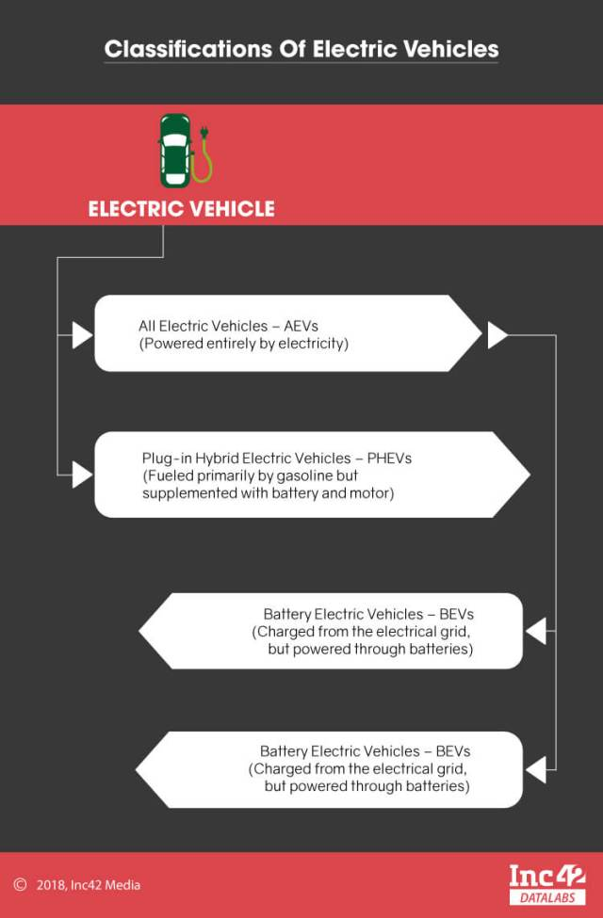
One of the chief features of electric vehicles is that they can be plugged into off-board power sources for charging. Essentially, there are two types of EVs: all-electric vehicles (AEVs) and plug-in hybrid electric vehicles (PHEVs). AEVs, in turn, consist of battery electric vehicles (BEVs) and fuel cell electric Vehicles (FCEVs). Both BEVs and FCEVs are charged from the electrical grid and are also usually capable of generating electricity through regenerative braking.
Because these types of vehicles don’t consume fossil fuels such as petroleum, they do not produce any tailpipe emissions. PHEVs (plug-in hybrid electric vehicles), on the other hand, are fueled primarily by gasoline and only supplemented with battery and motor for better efficiency.
In PHEVs, a battery, which can be plugged into the electric grid for charging, is used to power an electric motor, while gasoline drives the internal combustion engine. Certain types of plug-in hybrid electric vehicles are also known as extended-range electric vehicles (EREVs).
Often times, PHEVs utilise electricity for shorter ranges (around 9.6 to 64.3 km). Once the battery is depleted, they switch to the internal combustion engine for greater speed and range. More eco-friendly varieties of plug-in hybrids, at times, use hydrogen fuel cells, biofuels or some other kind of alternative fuel in place of gasoline.
There is a third category: conventional hybrids such as Toyota Prius, which is fitted with a petrol tank and also has a battery that gets charged every time the vehicle brakes. However, they can’t be classified as EVs because they usually cannot be plugged-in.

The Current State Of The Global EV Market
As more and more governments across the world are aggressively looking for ways to benefit from the ongoing EV revolution, the market opportunity in the space has grown dramatically over the years. Thanks to the push from local governments and corporates, the sector is expected to grow at a CAGR of 28.3% between 2017 and 2026, as per BIS Research.

Related Article: Electric Vehicles This Week: Fame-II Deferred Indefinitely, Agency Needed To Promote EVs Says Study, And More

For the first time in 2015, the global electric vehicle fleet surpassed 1 Mn, which was later doubled in 2016.
Here are some stats that highlight the sector’s rising potential:
- New registrations of electric cars hit an all-time high in 2016, with over 750K sales worldwide, according to the International Energy Agency (IEA).
- With a 29% market share, Norway currently boasts the most successful deployment of electric vehicles globally, followed by the Netherlands at 6.4% and Sweden with 3.4% market share. Recently, the Scandinavian nation of Norway set a new world record, with electric and hybrid vehicles accounting for nearly 52% of its total car sales in 2017 against 40% in 2016.
- Coming closely behind are China, France and the United Kingdom, all of whom have electric car market shares close to 1.5% respectively.
- In 2016, China accounted for nearly 40% of the world’s total electric car sales. In fact, Chinese OEMs produced 43% of the 873K EVs built worldwide in 2016. With more than 200 Mn electric two-wheelers, 3.3 to 4 Mn low-speed electric vehicles (LSEVs) and over 300K electric buses (as of 2017), China is currently the global leader in the electric mobility race.
- In the second position, in terms of the number of EV sales, is the US.
- For the first time in 2015, the global electric vehicle fleet surpassed 1 Mn, which was later doubled in 2016.
In line with this growth, the market is expected to have more than 10.8 Mn units by 2026, as per a survey by BIS Research. Across the globe, some of the key players are Tesla Inc. (U.S.), BYD Company Limited (China), Volkswagen AG (Germany), Nissan Motor Corporation (Japan), and Mitsubishi Motors Corporation (Japan) among others.
Notable EV components manufacturers include Samsung SDI (South Korea), Automotive Energy Supply Corporation (Japan), LG Chem. (South Korea), Panasonic Corporation (Japan), and Continental AG (Germany), etc.

The Necessity Of Robust Support Infrastructure
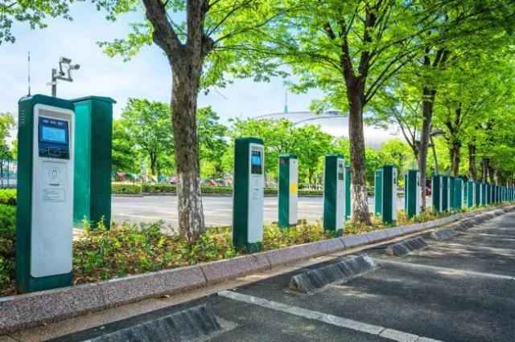
Just like conventional vehicles rely on petrol pumps or gas stations for refuelling, the mass adoption of electric vehicles mandates a robust charging infrastructure. Also called electric vehicle supply equipment (EVSE), the EV charging stations are often installed by utility companies as on-street facilities. Others are situated at shopping centres, public destinations and even workplaces and can be operated by private companies.
EVSEs are currently classified as per the rate at which the batteries get charged. In fact, the charging times of plug-in electric vehicles are dependent on a number of factors: the level of depletion, its energy storage capacity as well as the type of EVSE. The charging process can take anywhere between 30 minutes (fast charging) up to 24 hours, depending on the specifications of the battery and the charger.
Currently, there are two main types of plug-in EV charging stations: AC and DC. An AC charging station supplies current to the on-board vehicle charger and typically offers 8 to 24 km range per 30 minutes of charging. A DC charging station supplies current directly to the car’s battery and can provide up to 129 km of electric range for every 30 minutes charge.
Fast charging (more than 40 kW), on the other hand, delivers over 100 km of a range within 10 to 30 minutes. Currently, it takes a little over an hour to fully charge a Tesla car at one of the firm’s supercharging stations. By switching out the battery pack, however, drivers could find themselves back on the road much sooner. This is essentially how the battery swapping system works.
The global EV charging infrastructure market is expected to skyrocket to $45.59 Bn by 2025.
Last year, for instance, Tesla filed a patent for a new battery swapping robot that can lift a vehicle and change its battery pack for a new one in just 15 minutes. This was in line with the company’s vision to make almost nonstop travel during long road trips possible with electric cars.
With the growing popularity of electric vehicles, the global EV charging infrastructure market is expected to skyrocket to $45.59 Bn by 2025, as per a report by Grand View Research. Within this sector, the fast charging segment is poised to witness the fastest growth, with an estimated CAGR of around 47.9% from 2017 to 2025, the report by Grand View Research predicts.
As of December 2017, there were an estimated 20,178 EV public and private charging sites in the US, of which around 86.9% were available to the public. Japan, on the other hand, has more than 2,800 DC fast charging stations.
According to a study by IHS Inc., the number of EV charging units will increase exponentially from 1 Mn units in 2014 to more than 12.7 Mn units in 2020. Additionally, approximately 10% of EV charging stations globally will be in the public or semi-public domain by 2020.

Innovation: Key To The Growth Of The Electric Vehicle Market
“Changes call for innovation, and innovation leads to progress.” – Li Keqiang.
Today, driving the growth in the global EV market is innovation. With some of the best minds working to develop low-cost, eco-friendly electric mobility solutions, the sector is set to undergo substantial augmentation in the coming years.
Some of the groundbreaking EV technologies that are currently in the development phase include wireless charging as well as new types of batteries created with materials that are abundantly available in nature.
Wireless charging, as its name suggests, is a technology that could altogether eliminate “range anxiety” that is common among EV owners. Through this solution, electric vehicles could not only charge batteries with the help of a cable charger but also wirelessly by using magnetic resonance based on oscillating magnetic fields.
While the technology is being developed by MIT scientists, commercially, companies like WiTricity are currently working to manufacture devices for the wireless energy transfer.
Another area of innovation, pertaining to electric vehicles, is the development of new types of efficient batteries. While lithium-ion batteries are commonly used today to power electric vehicles, the inadequate available and high costs of the raw materials now pose a serious hindrance to the burgeoning EV market.
To counter this problem, the scientific world is now doubling down to find alternatives to Li-Ion batteries. In terms of viability, some of the emerging battery solutions that could be used to power electric cars of the future include solid-state batteries, which essentially have solid components. These have several advantages over conventional batteries such as no electrolyte leaks or fires, extended lifetime and the ability to operate in an extended temperature range.
Lithium-sulphur batteries and metal-air batteries are some of the technologies that could potentially benefit the electric car industry.

Why EV Adoption Is Crucial For India
Home to one of the largest automobile industries in the world, India currently contributes a major percentage of the global car sales. Public transport continues to be the primary mode of transport in tier II, tier III cities and rural regions. Given that over 1.2 Mn deaths occur in the country every year as a result of air pollution, according to a report by Greenpeace, the transition to more eco-friendly and renewable sources of energy is the need of the hour for India.
In light of the growing pollution problem, the Government of India, over the last few years, has been increasingly promoting alternative mobility solutions, chief among which are electric vehicles. Because they are powered by electricity and not fossil fuels, EVs are relatively emission-free and therefore, hold the key to India’s burgeoning air pollution issue.
Along those lines, the government unveiled the “National Electric Mobility Mission Plan (NEMMP) 2020” in 2013, under which it has rolled out a slew of initiatives and programmes geared towards accelerating the adoption of electric vehicles in India. The plan, essentially, aims to deploy around 7 Mn hybrid and all-electric vehicles in the country by 2020.
Realising the potential of EVs, the Indian government has also announced plans to make the country a 100% electric vehicle nation by 2030. To that end, in January 2017, the central government said that it would bear up to 60% of the research and development (R&D) cost for developing the indigenous low-cost electric technology.
National Electric Mobility Mission Plan (NEMMP) 2020, essentially, aims to deploy around 7 Mn hybrid and all-electric vehicles in the country by 2020.
Having already floated two global tenders for the procurement of up to 20,000 EVs, the government, under the leadership of PM Narendra Modi, is now planning to extend financial support of up to $1.3 Bn (INR 8,730 Cr) under the second phase of FAME India.
While think tank NITI Aayog has created a special task force to come up with suggestions for the Union government, in a bid to make the transition to electric vehicles more seamless, various state governments have unveiled or are in the process of launching dedicated policies on EVs.
In September 2017, for instance, Karnataka became the first Indian state to roll out its Electric Vehicle and Energy Storage Policy. Similarly, in October, the Telangana government prepared a draft policy on electric vehicles, with a focus on benefits for EV manufacturers.
Among the other states that have rolled out – or are in the process of launching – policies on electric vehicles are Maharashtra, Andhra Pradesh, Goa, Uttar Pradesh and others. Interestingly, Gujarat, WB, UP, Rajasthan and Maharashtra clocked the highest number of EV sales during FY2016-17, according to a report by the Society of Manufacturers of Electric Vehicles (SMEV).
As per the findings of the study, Gujarat topped the list with sales of just over 4,330 units. WB appeared in the second place with sales of 2,846 units, followed by UP which sold a total of 2,467 electric vehicles during the said period. Rajasthan reported sales of around 2,388 EV units, while Maharashtra came in fifth with sales of 1,926 units.
“In addition, 25,000 e-vehicles were sold across India between 2016-17. The study was conducted on all electric two-wheelers and four-wheelers which were sold during 2016-2017 and are successfully running in the mentioned states,” stated the report.
In another study, ASSOCHAM and EY claimed that the electric vehicles (EV) market is expected to record double-digit growth rates with the rise in sales volume annually in India till 2020. The survey titled ‘Electric mobility in India: Leveraging collaboration and nascency’, further said that despite electric vehicles not being mainstream, stricter emission norms, reducing battery prices and increasing consumer awareness are driving EV adoption in India.

Electric Vehicles: The Future Of Mobility
Globally, automobile exhaust is one of the biggest contributing factors of pollution, especially air pollution. While the environmental impact of electric vehicles is somewhat obvious, there are other advantages to electric mobility solutions that conventional fossil fuel-powered vehicles don’t have.
Keeping that in mind, here is a rundown of the some of the major advantages and disadvantages of electric vehicles over regular petrol or diesel-fuelled cars.
Here are the key advantages Of EVs:

No Fuel, Cheaper To Maintain
Because electric cars are powered by electricity and not gasoline, it drastically reduces the monthly spendings of car owners. According to Bloomberg, the consumption of fossil fuels by automobiles currently stands at 23 Mn barrels per day. However, with the increased popularity of EVs, the global gasoline consumption in the passenger vehicle segment will drop significantly within the next five years, as per a report by the International Energy Agency.
Although the initial cost of electric cars is quite higher than that of conventional vehicles, in the long-run, it is actually cheaper to own and maintain EVs. Ergon Energy states that the electricity needed to charge an EV is, on an average, around a third of the price of petrol per kilometre, especially in developed countries.
Similarly, a battery electric vehicle (BEV) contains fewer components than a conventional petrol/diesel car, making servicing and maintenance a lot cheaper than petrol and diesel-powered vehicles.

More Eco-Friendly, Lower Carbon Footprint
Given that the number of air pollution-related deaths have been on the rise lately, switching to electric cars, especially when it comes to public transport, could potentially reduce carbon emissions, thus slowing down climate change and global warming.
In fact, electric cars are 100% emission free as they run on electrically powered engines. Consequently, they do not emit any toxic gases or smoke that could adversely affect the environment. In this count, all-electric cars – particularly the ones powered by renewable energy – are much better than hybrid cars.
However, in this regard, it should be noted that the source of electricity is also of importance in case of EVs. If the electricity is produced through environmentally-damaging means like coal power plants, which is often the case in developing countries, the environmental benefits of electric cars ultimately get negated.

Less Noise Pollution, Smoother Ride
Since they are devoid of internal combustion engines and, in general, have less number of components, electric vehicles tend to be more silent than conventional vehicles. This, in turn, helps in curbing noise pollution, especially in crowded urban areas.
As an added advantage, electric motors, being lighter, offer a smoother drive with higher acceleration over longer distances than cars running on fossil fuels.
Now, let’s look at some of the disadvantages of EVs:

Range Anxiety, Lack Of Charging Infrastructure
Despite the massive technological advancements, EV charging infrastructure remains inadequate in most parts of the world. Furthermore, most electric cars have a range that falls between 150 to 175 km on a single charge. This, inevitably, gives rise to range anxiety among car owners.
In the absence of charging points, especially during low-distance drives, there is the risk of being stranded, which albeit can be avoided through battery swapping. However, for widespread adoption of EVs, governments around the world need to be more proactive in building a robust and well-connected charging infrastructure.

Long Charging Times
As mentioned above, the charging process of EVs can take anywhere from 30 minutes (in case of fast charging) up to 24 hours, depending on the capacity of the battery and motors. Most, however, take around four to six hours to be fully charged, which is several times longer than the time it takes to refuel a petrol/diesel car.

Lower Battery Life, High Battery Costs
The batteries currently used in electric vehicles have a lifespan of only around three to 10 years, depending on the make and model. The lower battery life often serves as a hindrance that affects the performance of electric cars. The higher costs of batteries, which are caused by the insufficient supply of raw materials, add to this problem.

In Conclusion
From the first electric car developed in 1837 till the present times, we have witnessed massive advancements, notably in terms of technology but also in the people’s attitude towards the environmental impact of cars and other mobility solutions.
While the electric vehicles market is currently a lucrative destination for corporates and startups in India, there are still quite a few challenges that need to be overcome to make EVs ready for mass adoption. Manufacturing electric vehicles domestically, for instance, comes with the hurdle of high costs.
Similarly, production of batteries is largely an expensive affair. To be able to rise above these challenges, the Indian government will have to focus its efforts on facilitating technological disruption. For faster adoption of EVs, the government will also have to offer greater tax rebates and subsidies to prospective car owners and manufacturers.
If successful, the shift to electric vehicles could potentially help India save up to $300 Bn (INR 20 Lakh Cr) in oil imports and nearly 1 gigatonne of carbon dioxide emissions by 2030, as per a recent report by FICCI and Rocky Mountain Institute! Furthermore, EVs will be a stepping stone towards designing an intelligent, futuristic transport infrastructure in India that is capable of catering to the mobility needs of the country’s huge population.

